EXPERIMENT : 02

NAME : KIRUTHICK.SM ROLL NO : 240701262

Experiment: Visual Memory Recall Test
Aim:
To evaluate the participant’s ability to observe, remember, and recall visual icons.
Objective:
The experiment measures short-term visual memory by asking participants to observe a set of icons and later identify them from a recall screen.
Procedure:
- The participant first reads the instructions displayed on the screen carefully.
- A set of icons is shown to the participant for a limited period of time.
- The participant must observe the icons closely and try to remember them.
- After the observation phase, a recall screen appears containing multiple icons.
- The participant selects the icons that were previously displayed.
- Once the selection is completed, the system evaluates the responses.
- The participant’s score is then displayed based on the number of correct selections.
Result / Outcome:
The score reflects the participant’s visual memory and recall ability. Higher scores indicate better short-term visual memory performance.
Conclusion:
This experiment helps analyze how effectively a person can encode, store, and retrieve visual information within a short period.

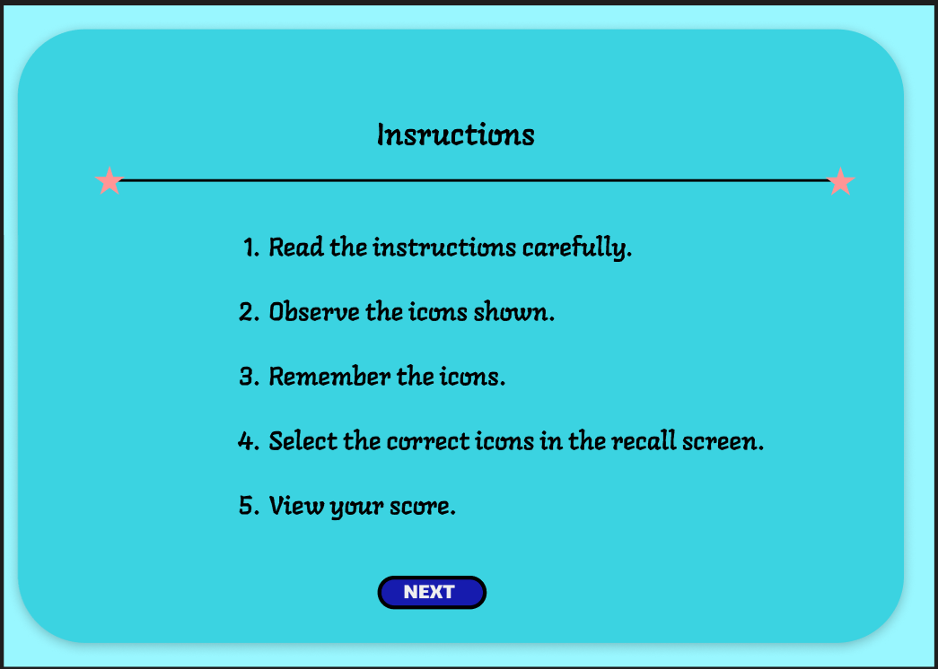

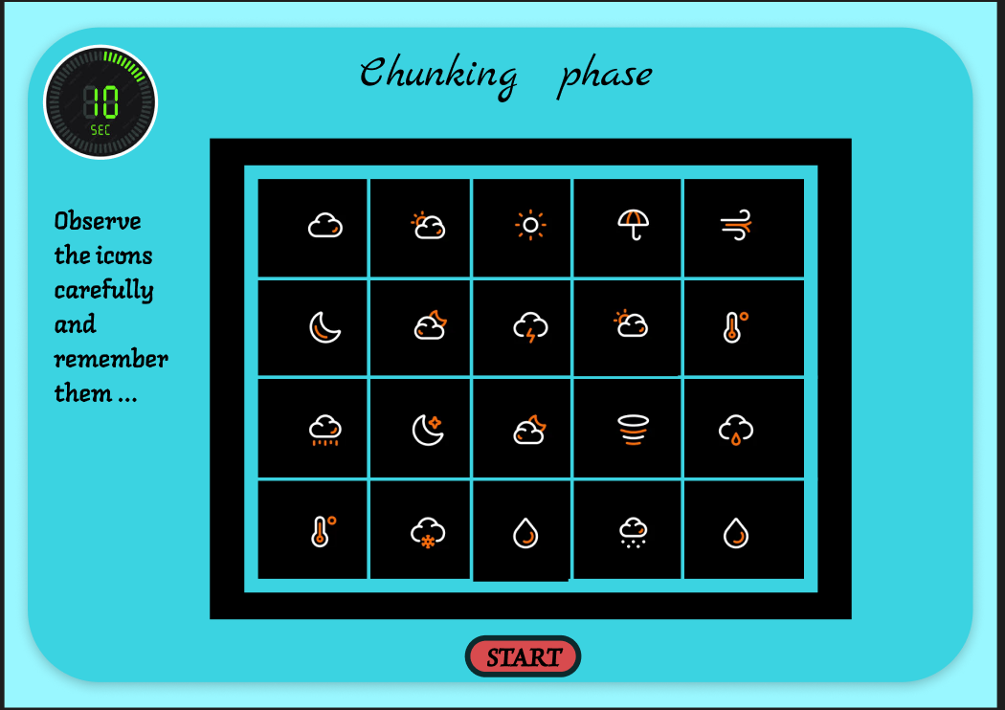

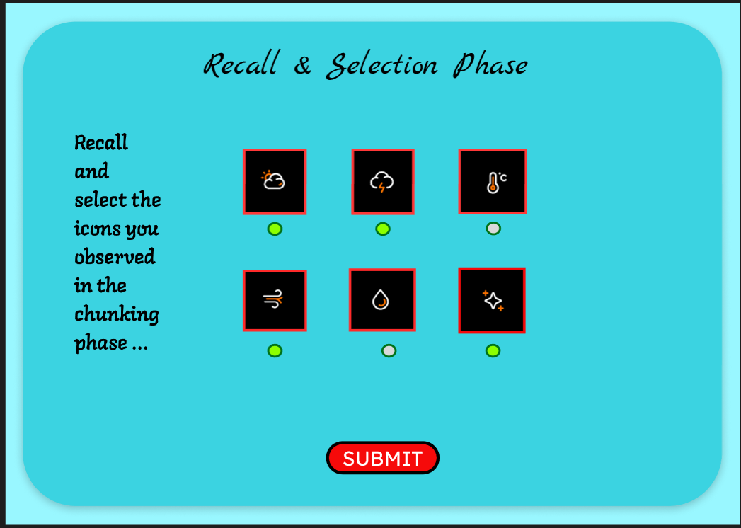

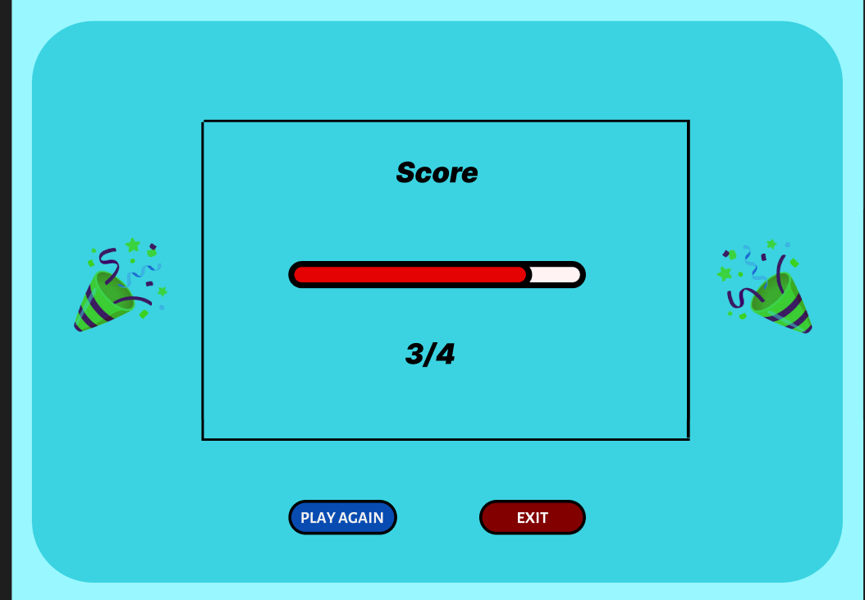

LINK:

https://www.figma.com/design/bZgw4VOrtYMpS9EZxEg7jf/EXPERIMENT-2?node-id=0-1&t=5y8UAy86kvwGt0RS-1

